Bellbrook Music Boosters
13Sept2021
7:15 pm
BHS Cafeteria
General Membership Meeting Minutes

Call to Order: 7:22 pm
Roll Call: Appendix A
Welcome:
Approval of the General Meeting Minutes, 02Aug2021:
Phoebe Dickman, 1st motion, Jon Selvaraj, 2nd, All Approved
Old Business:
- Lego Raffle Fundraiser
  - The fundraiser was a great success, with $1,000 earned for the Bellbrook Music Boosters.
  - Future raffles are planned for: The Bellbrook Invitational, Christmastime, and Springtime.

- Tag Day #1
  - Director Andy Soloman reported that the first Tag Day of 2021 earned the Bellbrook Music Program over $6,800, $600 of which was in coins.
  - Mr. Soloman offered a huge thank you to all of the parents who volunteered to be drivers for the event.
New Business

- Treasurer’s Report-Appendix B

- Board of Trustees’ Report
  - Fundraising Trustee Rod Silva is absent tonight. However, he informed Trustee Chair Larissa Scott that he is still working on obtaining sponsors for the Bellbrook Invitational. He asks for anyone to contact him if they might have additional leads for sponsors.

- Officer’s Report
  - President Melanie Glover has nothing to report at this time.

- Director’s Report- Appendix C.
  - Director Barb Siler further discussed the 21Oct2021 Fall Band Concert for the High School Symphony Band and Wind Ensemble.
    - At this concert there will be the World Premier of John Mackey’s piece: “Some Treasures are heavy with human tears”.
    - This piece was commissioned by Bellbrook’s Director of Concert Bands, Barbara Siler, and paid for by a consortium of local high school and secondary music programs.
    - This musical piece commemorates the victims of the 2019 Oregon District mass shooting that claimed the lives of ten individuals, two of whom where Bellbrook graduates and members of our Music Program.

- Administrator’s Report
    - Vice Principal Todd Whalen was present for the Executive Board meeting, but he is not present at this meeting. The Administration continues to offer their full organizational and logistical support to all of Bellbrook’s Music Programs.

- Meal planning for:
- BOA Dayton (18Sept2021)
- BOA Obetz (25Sept2021)
  - Becky Hobbs will Chair the Food Committee for both BOA Regional events.
  - She will be using the Bird Feeder due to all of its’ amenities and will be recruiting volunteers to help serve.
  - We will be requesting a payment of $10 per student to help offset both meals.

- Fall Invitational: MSBA Bellbrook, 02Oct2021
  - Kristin Selvaraj is Chair and Melanie Glover is the Co-Chair of the event.
  - All committees have a chair except for three: ticket sales, concessions, and the Lego raffle.
  - The next Invitational Meeting is 14Sept2021 at 7 pm in the High School Cafeteria. All are welcome and encouraged to attend.

- Fundraising

  - Tag Day #2
    - The second Tag Day will be on 29Sept2021 from 5:30-8:30 pm, with pizza provided afterwards.
    - We will once again be asking for parent drivers to make sure that our second day is as successful as the first.

  - Dine Outs
    - The next event is at: Chipotle Dine Out: 14Sept2021, Sugarcreek Plaza location.

- Spring Flower Sale
  - Karen Beildelchies will be the chair of the 2022 Bellbrook Music Boosters Spring Flower Sale.
  - President Melanie Glover reports that a representative from Foertmeyer & Sons Greenhouse gave a presentation about their fundraising program to the Executive Board.
  - The Executive Board will need to synthesize a large amount of information and distill it down for the General Membership.
  - Stay tuned…

- Open Forum

- Connor Flanagan’s Eagle Scout Project:
  - Connor gave a presentation to the General Membership.
    - For his project, he is: reinforcing the band tower/scaffolding, building a cement pad, and placing fencing around it.
      - BHS has requested the fencing for safety. A six-foot fence is being installed which will have a locking gate, for which only the Directors will have the keys.
    - Donations that Connor has received thus far: $1,500 in cement and $2,000 in fencing.
    - Connor is requesting a donation of:
      - $200 in Lowe’s Gift Cards from the Bellbrook Music Boosters in order to complete the project: He needs to purchase clips and tension rods for nine fence posts, as swell as caps for the top of the posts.
    - Connor reports that Mr. Brett Woeste will manage the donated funds and return to the BMB will receipts.
    - The BMB Executive Board will consider Connor’s request, and President Melanie Glover will communicate the Board’s decision to Connor.

Adjourn: 8:06 pm
- Jon Selvaraj, 1st motion, Larissa Scott, 2nd

APPENDIX A

Roll Call, 13Sept2021:
- Melanie Glover
- Heather Newell
- Kevin Hobbs
- Larissa Scott
- Andy Soloman
- Barb Siler
- Rachele Alban
- Jon Selvaraj
- Karen Beildelchies
- Phoebe Dickman
  - Absent: Danielle Woeste, Jen Volmer, Rod Silva, Barb Siler Kristin Selvaraj

- Tracey Waller
- Nick Falzerano
- Becky Hobbs
- Tessa Blachly-Flanagan
- Daniel Waugh

APPENDIX B
Treasurer Report
13Sept2021
Page 1/6

Balances
Checking $30,539.26
Savings $64,520.78

Booster Funds Overview:
Fiscal YTD Revenue: $ 2,599.58
Fiscal YTD Expenses: 9,207.96
Fiscal YTD Surplus/(Deficit): $ (6,608.38)

Monies Received from Donations/Fundraisers
# | Source | Amount
1 | Panda Express - Dine-In | $ 247.90
2 | Amazon Smile | 197.19
3 | Lego Raffle | 1,000.00
4 | Kroger Rewards | 554.49
5 | Boeing | 100.00
6 | Schott’s Plumbing – Sponsorship | 500.00

Treasurer Activities/Notes/To-Do’s
- Reimbursement for 2020-2021 Winter Guard expenses (Sheldon)
- Document Future Needs (Uniforms, Replacement of worn-out assets)
- Draft of Treasurer’s Playbook

Graphs: see below

APPENDIX B
Treasurer Report
13Sept2021
Page 2/6

APPENDIX B
Treasurer Report
13Sept2021
Page 3/6

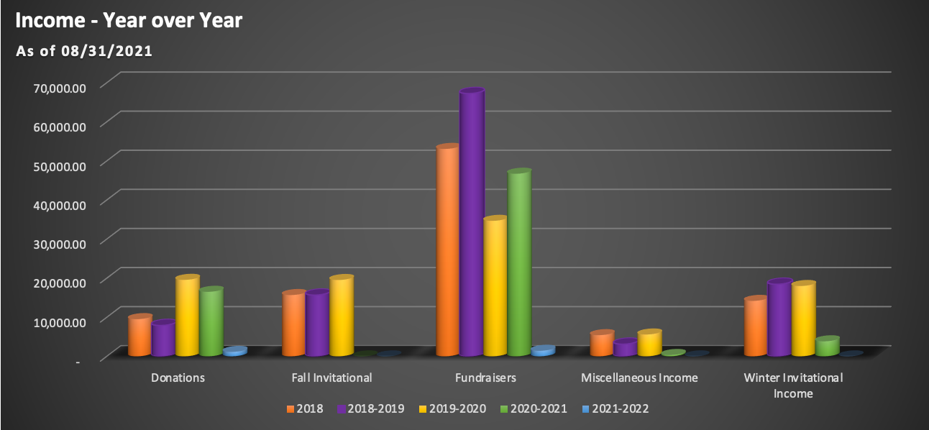

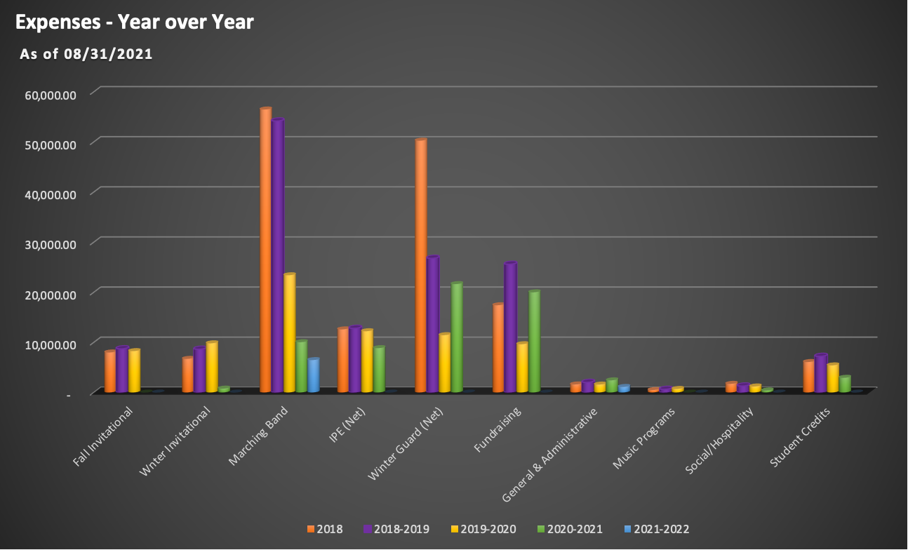
APPENDIX B
Treasurer Report
13Sept2021
Page 4/6

APPENDIX B
Treasurer Report
13Sept2021
Page 5/6

APPENDIX B
Treasurer Report
13Sept2021
Page 6/6

APPENDIX C
Director’s Report
13Sept2021

- A HUGE thanks to everyone who helped make Tag Day #1 a success! Tag Day #2 (date proposal Wednesday, September 29)
- As we get into the competitive season, please continue to communicate with directors about any absences ahead of time whenever possible
- We are excited to perform this weekend and next weekend at BOA regionals for the first time since 2019!
  - BOA Details - 18 bands, 12 make finals
  - Regional Retreat - possible change to drum majors only
  - Regional timing and penalties update
- 8th Grade Night is Friday - our full 8th grade band has been learning music and will be joining the marching band for a special halftime performance. The Marching Eagles will be performing a POST GAME performance of Out of the Blue for the 8th graders and fans in the bleachers
- Bellbrook Invitational -
  - no new bands have joined
  - 2 judges, confirmed no travel needs
  - Positive feedback from colleagues, however most bands are already committed to another
- Awesome performance by the Marching Eagles at the Lions Club Festival and first several football games!
- We are working hard on our October concert music, including “some treasures are heavy with human tears” by John Mackey.
  - MS 7th/8th Concert on October 7th at 7pm, BHS Auditorium
  - HS Concert on October 21, BHS Main Gym
- Deposit has been made on the senior New York trip flight!
- Please continue checking Remind/Charms email/HUB for marching band updates

